Start of Game  Who Has:  A polygon surrounded by a circle, where each  of its vertices fall on the circle?  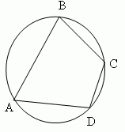 |  | I Have: Inscribed polygon  Who Has:  A number, a variable, or a product of a number and one or more variables (e.g., 7ab)?
I Have: Monomial  Who Has:  The combined set of rational and irrational numbers? |  | I Have: Real Numbers  Who Has:  A polynomial with three terms  (e.g., 7a + 4b + 9c)?
I Have: Trinomial  Who Has:  A number’s distance from zero on a number  line? |  | I Have: Absolute Value  Who Has:  Two events in which the outcome of one event affects the outcome of the other event?
I Have: Dependent Events  Who Has:  Numbers that cannot be written as a ratio of  two integers?  Hint: It is a non- repeating, non-terminating  decimal. |  | I Have: Irrational Number  Who Has:  A line that intersects a circle in exactly two  points?  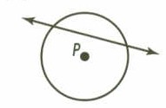
I Have: Secant  Who Has:  A branch of geometry in which points are represented with respect to a coordinate system, and in which the approach to geometric problems is primarily algebraic? |  | I Have: Analytic Geometry  Who Has:  An algebraic expression that contains one or  more monomials?
I Have: Polynomial  Who Has:  A ray in the interior of an angle, whose endpoint is the vertex of that angle, and divides the angle into two congruent angles?  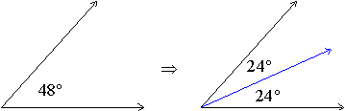 |  | I Have: Angle Bisector  Who Has:  Two quantities that are inversely related,  described by an equation of the form xy = k  or y = k/x, where k is a constant not equal to  zero?
I Have: Inverse Proportion  Who Has:  Equations which are expressed in the form y = ax² + bx + c, where a is not equal to zero? |  | I Have: Quadratic Function  Who Has:  A line drawn on a scatter plot to best estimate the relationship between two sets of data?
I Have: Line of Best Fit (Regression Line)  Who Has:  An arc of a circle whose endpoints are the  endpoints of a diameter? |  | I Have: Semicircle  Who Has:  A polynomial with two terms (e.g., 7a + 4b)?
I Have: Binomial  Who Has:  The difference between the first and third quartile? |  | I Have: Interquartile Range  Who Has:  The point on a line segment that is halfway between the endpoints of that segment?
I Have: Midpoint  Who Has:  A line that touches a circle in exactly one  point?  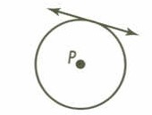 |  | I Have: Tangent  Who Has:  A continuous part of a circle between two  points on the circle?
I Have: Arc  Who Has:  Two quantities that always have a constant  ratio, described by an equation of the form  y = kx, where k is a constant not equal to zero? |  | I Have: Direct Proportion  Who Has:  An angle whose vertex is on the circle and  whose sides are chords of the circle?  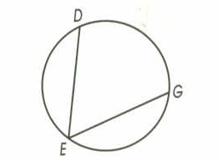
I Have: Inscribed Angle  Who Has:  A polygon that surrounds a circle with each of  its sides tangent to the circle?  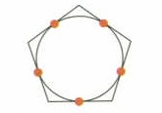 |  | I Have: Circumscribed Polygon  Who Has:  The ratio of the number of ways the event can  occur (successes) to the number of ways the  event cannot occur (failures)?
I Have: Odds  Who Has:  An angle whose vertex is the center and whose sides are the radii of the circle or an angle whose vertex is the center and whose sides intersect the regular polygon at adjacent vertices? |  | I Have: Central Angle  Who Has:  A number that can be expressed as a ratio of two integers? Or, a number that can be expressed in the form a/b, where a and b are integers and b is not equal to zero?
I Have: Rational Number  Who Has:  A segment drawn from a vertex of a triangle  and perpendicular to the opposite side or to  the line containing the opposite side? |  | I Have: Altitude  Who Has:  What can be described by an equation of the form y = a^{x}, where a > 0 and a does not equal 1?
I Have: Exponential Function  Who Has:  A value that is much greater or much less  than the rest of the data? |  | I Have: Outlier  Who Has:  A line segment that connects a vertex of a  triangle to the midpoint of the side opposite  that vertex?
I Have: Median  Who Has:  The ratio of the change in the vertical  distance to the change in the horizontal  distance of two points on a line and measures  the steepness of a line from left to right; also  described as the  change in y, or rise ?  change in x run |  | I Have: Slope  End of Game

