Start of Game  Who Has:  A triangle that has each angle measuring less  than 90°? |  | I Have: Acute Angle  Who Has:  An event made up of two or more simple  events?
I Have: Compound Event  Who Has:  A triangle whose sides are all the same length? |  | I Have: Equilateral Triangle  Who Has:  Rules describing what sequence to use in  evaluating expressions. (1) Perform operations in  grouping symbols, (2) Evaluate exponents, (3)  Multiply or divide from left to right, (4) Add or  subtract from left to right?
I Have: Order of Operations  Who Has:  A pair of opposite congruent angles formed when  two lines intersect?  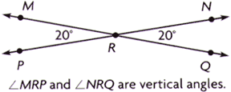 |  | I Have: Vertical Angles  Who Has:  A graphic method for showing a summary of data using median, quartiles and extremes of data?  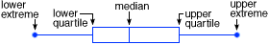
I Have: Box-and-Whisker Plot  Who Has:  An equation whose graph in a coordinate plane  is a straight line? |  | I Have: Linear Function  Who Has:  Angles that share a common side and common vertex and do not overlap?  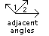
I Have: Adjacent Angles  Who Has:  A two-dimensional system in which the coordinates of a point are its distances from both a horizontal and a vertical line called the axes? |  | I Have: Coordinate Plane/Graph  Who Has:  The point at which the two axes intersect has the coordinates (0,0)?
I Have: Origin  Who Has:  A pair of angles located outside a set of parallel lines and on opposite sides of the transversal? |  | I Have: Alternate Exterior Angles  Who Has:  Two events that cannot occur at the same time?
I Have: Mutually Exclusive Events  Who Has:  An equation showing that two ratios are equal? |  | I Have: Proportion  Who Has:  The sum of the areas of all of the faces of a  three-dimensional figure?
I Have: Surface Area  Who Has:  A pair of angles located between a set of  parallel lines and on opposite sides of the  transversal? |  | I Have: Alternate Interior Angles  Who Has:  Two events in which the outcome of one event  does not affect the outcome of the other event?
I Have: Independent Events  Who Has:  A three-dimensional solid that has two congruent and parallel faces that are polygons?  HINTS: The remaining faces are rectangles.  They are named by their bases. |  | I Have: Prism  Who Has:  Two angles whose measures, when added  together, equal 90°?
I Have: Complementary Angles  Who Has:  The first number, called the x-coordinate, designates the distance along the horizontal axis. The second number, called the y-coordinate, designates the distance along the vertical axis? |  | I Have: Ordered Pairs  Who Has:  When a transversal intersects two lines, these are on the same side of the transversal and on the same side of the given lines or angles in the same relative position in similar or congruent figures?
I Have: Corresponding Angles  Who Has:  A statement of probability based on the results of a series of trials? |  | I Have: Experimental Probability  Who Has:  A triangle that has exactly two congruent sides?
I Have: Isosceles Triangle  Who Has:  Possible orders, or arrangements of a set of  items? |  | I Have: Permutations  Who Has:  A form of writing very large or very small numbers using a number greater than or equal to 1 and less than 10 multiplied by a power of 10  (e.g., 4.7 x 10⁹ = 4,700,000,000)?
I Have: Scientific Notation  Who Has:  A two-dimensional shape that can be folded to  create a three-dimensional figure? |  | I Have: Net  Who Has:  A graph with points plotted to show a relationship between two variables?  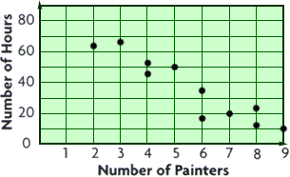
I Have: Scatterplot  Who Has:  The product of an integer multiplied by itself? |  | I Have: Perfect Square  Who Has:  A data display that shows groups of data arranged by place value?  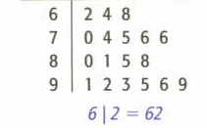
I Have: Stem-and-Leaf Plot  Who Has:  A triangle with one angle that measures more  than 90º? |  | I Have: Obtuse Angle  Who Has:  A triangle with no congruent sides?
I Have: Scalene Triangle  Who Has:  A formula for finding the length of a side of a right  triangle when the lengths of two sides are given?  a² + b² = c² |  | I Have: Pythagorean Theorem  Who Has:  Two angles whose measures, when added  together, equal 180°?
I Have: Supplementary Angles  Who Has:  A statement of the probability of an event without  doing an experiment or analyzing data? |  | I Have: Theoretical Probability  End of Game

