Mathematics Assessment Anchor Glossary
Grades 7 & 8

The definitions for this glossary were taken from one or more of the following sources: Webster’s Dictionary, various mathematics dictionaries, the PA Mathematics Standards glossary and various textbook glossaries.

Acute triangle: A triangle that has each angle measuring less than 90°.

Adjacent angles: Angles that share a common side and common vertex and do not overlap.
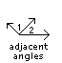

Alternate exterior angles: A pair of angles located outside a set of parallel lines and on opposite sides of the transversal.
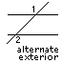

Alternate interior angles: A pair of angles located between a set of parallel lines and on opposite sides of the transversal.
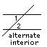

Box-and-whisker plot: A graphic method for showing a summary of data using median, quartiles and extremes of data.

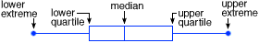

Complementary angles: Two angles whose measures, when added together, equal 90°.

Compound event: An event made up of two or more simple events.

Coordinate plane/graph: A two-dimensional system in which the coordinates of a point are its distances from both a horizontal and a vertical line called the axes. The pairs of numbers are called ordered pairs. The first number, called the x-coordinate, designates the distance along the horizontal axis. The second number, called the y-coordinate, designates the distance along the vertical axis. The point at which the two axes intersect has the coordinates (0,0) and is called the origin.
y

x
Corresponding angles (1): When a transversal intersects two lines, corresponding angles are on the same side of the transversal and on the same side of the given lines. In the figure below, angles 1 and 2 are corresponding.

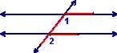

Corresponding angles (2): Angles in the same relative position in similar or congruent figures.

Equilateral triangle: A triangle whose sides are all the same length.

Experimental probability: A statement of probability based on the results of a series of trials.

Independent events: Two events in which the outcome of one event does not affect the outcome of the other event.

Isosceles triangle: A triangle that has exactly two congruent sides.

Linear function: An equation whose graph in a coordinate plane is a straight line.

Mutually exclusive events: Two events that cannot occur at the same time.

Net: A two-dimensional shape that can be folded to create a three-dimensional figure.

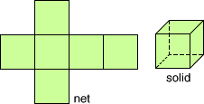
figure
net

Obtuse triangle: A triangle with one angle that measures more than 90º.

Order of operations: Rules describing what sequence to use in evaluating expressions. (1) Perform operations in grouping symbols, (2) Evaluate exponents, (3) Multiply or divide from left to right, (4) Add or subtract from left to right.

Perfect square: The product of an integer multiplied by itself (e.g., 121 is a perfect square because 11x11=121).

Permutation: Possible orders, or arrangements of a set of items. Placing these items in a different order results in a new permutation.

Prism: A three-dimensional solid that has two congruent and parallel faces that are polygons. The remaining faces are rectangles. Prisms are named by their bases.

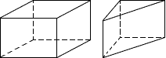
rectangular prism triangular prism

Proportion: An equation showing that two ratios are equal.

Pythagorean theorem: A formula for finding the length of a side of a right triangle when the lengths of two sides are given. (leg² + leg² = hypotenuse ² or a² + b² = c²)

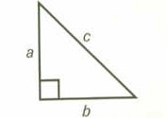

Scalene triangle: A triangle with no congruent sides.

Scatterplot: A graph with points plotted to show a relationship between two variables.

Amount of Time to Paint a House
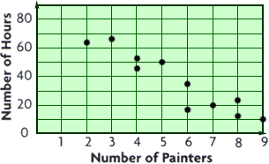

Scientific notation: A form of writing very large or very small numbers using a number greater than or equal to 1 and less than 10 multiplied by a power of 10 (e.g., 4.7 x 10⁹ = 4,700,000,000).

Stem-and-leaf plot: A data display that shows groups of data arranged by place value.

Math Test Scores
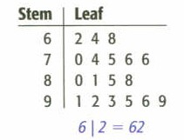

Supplementary angles: Two angles whose measures, when added together, equal 180°.

Surface area: The sum of the areas of all of the faces of a three-dimensional figure.

Theoretical probability: A statement of the probability of an event without doing an experiment or analyzing data.

Vertical angles: A pair of opposite congruent angles formed when two lines intersect.

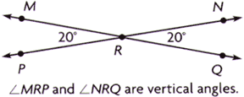 *Note: Angle MRN and angle PRQ are also vertical angles.

