Mathematics Assessment Anchor Glossary
Grade 11

The definitions for this glossary were taken from one or more of the following sources: Webster’s Dictionary, various mathematics dictionaries, the PA Mathematics Standards glossary and various textbook glossaries.

Absolute value: A number’s distance from zero on a number line. The absolute value of ⁺2 is equal to the absolute value of -2.

Altitude (of a triangle): A segment drawn from a vertex of a triangle and perpendicular to the opposite side or to the line containing the opposite side.

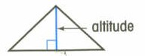

Analytic geometry: A branch of geometry in which points are represented with respect to a coordinate system, and in which the approach to geometric problems is primarily algebraic.

Angle bisector: A ray in the interior of an angle, whose endpoint is the vertex of that angle, and divides the angle into two congruent angles.
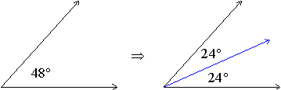The blue (middle) ray is the angle bisector.

Arc: A continuous part of a circle between two points on the circle.

Binomial: A polynomial with two terms (e.g., 7a + 4b).

Central angle:
- Of a circle: An angle whose vertex is the center and whose sides are the radii of the circle.
- Of a regular polygon: An angle whose vertex is the center and whose sides intersect the regular polygon at adjacent vertices.

Circumscribed polygon: A polygon that surrounds a circle with each of its sides tangent to the circle.

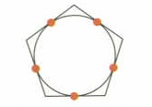

Dependent events: Two events in which the outcome of one event affects the outcome of the other event.

Direct proportion: Two quantities that always have a constant ratio. A direct variation is described by an equation of the form y = kx, where k is a constant not equal to zero.

Exponential function: An exponential function is a function that can be described by an equation of the form y = a^{x}, where a > 0 and a does not equal 1.

Inscribed angle: An angle whose vertex is on the circle and whose sides are chords of the circle.
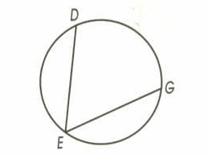

Inscribed polygon: A polygon surrounded by a circle, where each of its vertices fall on the circle.
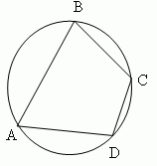

Interquartile range: The difference between the first and third quartile.

Inverse proportion: Two quantities that are inversely related. An inverse variation is described by an equation of the form xy = k or y = k/x, where k is a constant not equal to zero.

Irrational number: Numbers that cannot be written as a ratio of two integers. It is a non- repeating, non-terminating decimal.

Line of best fit (regression line): A line drawn on a scatter plot to best estimate the relationship between two sets of data.

Median (of a triangle): A line segment that connects a vertex of a triangle to the midpoint of the side opposite that vertex.

Midpoint: The point on a line segment that is halfway between the endpoints of that segment.

Monomial: A monomial is a number, a variable, or a product of a number and one or more variables (e.g., 7ab).

Odds: The odds of an event occurring is the ratio of the number of ways the event can occur (successes) to the number of ways the event cannot occur (failures).

Outlier: A value that is much greater or much less than the rest of the data is an outlier. More specifically, it is an element of a set of data that is 1.5 interquartile ranges greater than the upper quartile or less than the lower quartile.

Polynomial: An algebraic expression that contains one or more monomials.

Quadratic function: Equations which are expressed in the form y = ax² + bx + c, where a is not equal to zero.

Rational number: A number that can be expressed as a ratio of two integers. A rational number can be expressed in the form a/b, where a and b are integers and b is not equal to zero.

Real number: The combined set of rational and irrational numbers.

Secant (of a circle): A line that intersects a circle in exactly two points.

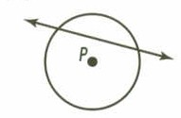

Semicircle: An arc of a circle whose endpoints are the endpoints of a diameter.

Slope: The ratio of the change in the vertical distance to the change in the horizontal distance of two points on a line. Slope measures the steepness of a line from left to right.
Slope = change in y, or rise
change in x run

Tangent (of a circle): A line that touches a circle in exactly one point.

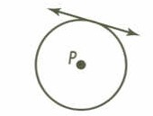

Trinomial: A polynomial with three terms (e.g., 7a + 4b + 9c).

