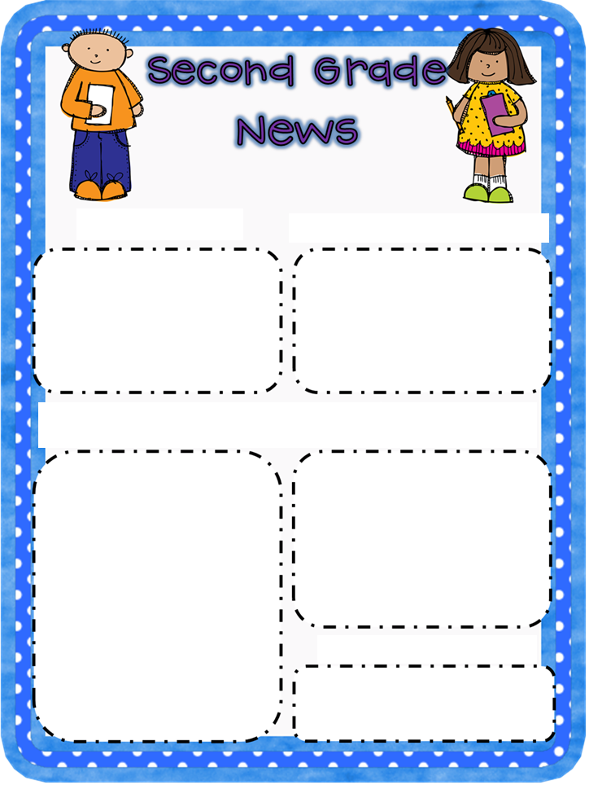
RecessI would like to tell you…

Frog and Toad

Created and written by: Miss Dunn’s second grade class

Type here
Type here
Type here
Type here
Frog And Toad

RECESS MY FAVORITE THING WE DID WAS..

Type here
Type here
Type here

