START OF GAME  Who has a line segment whose  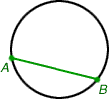  endpoints are on a circle? |  | I Have: Greatest Common Factor (GCF)  Who has a polygon with 9 sides?
I Have: Chord  Who has the distance around a circle? |  | I Have: Nonagon  Who has a whole number that has exactly two factors, 1 and itself?
I Have: Circumference  Who has the longest side of a right triangle (which is also the side opposite the right angle)? |  | I Have: Prime Number  Who has a way to write numbers that shows the value of each digit  (e.g., 4372 = 4000+300+70+2)?
I Have: Hypotenuse  Who has the largest factor that 2 or more numbers have in common? |  | I Have: Expanded Notation  Who has a decimal that has a repeating sequence of numbers after the decimal point?  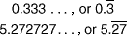
I Have: Repeating Decimal  Who has the moving of a figure by a translation (slide), rotation (turn) or reflection (flip)? |  | I Have: Plane  Who has a graph showing the frequency of data on a number line?  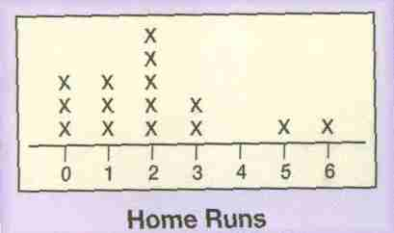
I Have: Transformation  Who has The price of a single item or amount (e.g., $3.50 per pound)? |  | I Have: Line Plot  Who has The least common multiple of the denominators in two or more fractions?
I Have: Unit Price  Who has a diagram that shows relationships among sets of objects?  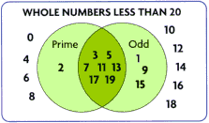 |  | I Have: Least Common Denominator(LCD)  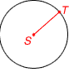  Who has a line segment that has one endpoint on a circle and the other endpoint at the center of the circle?
I Have: Venn Diagram  Who has A flat surface that extends infinitely in all directions? |  | I Have: Radius  Who has A whole number having more than two factors?
I Have: Composite Number  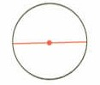  Who has A line segment that has endpoints on a circle and passes through the center of the circle? |  | I Have: Ratio  Who has: A polygon that has all sides congruent and all angles congruent?
I Have: Diameter  Who has the smallest number, other than zero, that is a common multiple of two or more numbers? |  | I Have: Regular Polygon  Who has an angle with a measure of 180º?
I Have: Least common multiple (LCM)  Who has A flat surface that extends infinitely in all directions? |  | I Have: Straight Angle  Who has Any of the numbers 0, 1, 2, 3, 4, 5, … (and so on)?
I Have: Plane  Who has A comparison of two numbers using division? |  | I Have: Whole Number  Who has the horizontal number line on a coordinate plane?
I Have: X-Axis  Who has Polygons that have the same shape, but not necessarily the same size. Corresponding sides of similar polygons are proportional? |  | I Have: Y-Axis  Who has A decimal that contains a finite number of digits?
I Have: Similar Polygons  Who has a polygon with 7 sides? |  | I Have: Terminating Decimal  Who has A rate with the second term being one unit (e.g., 50 mi/gal, 4.5 km/sec)?
I Have: Heptagon  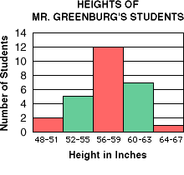  Who has A bar graph in which the labels for the bars are numerical intervals? |  | I Have: Unit rate  Who has A ratio that compares two quantities having different units (e.g., 95 miles in 2 hours)?
I Have: Histogram  Who has The vertical number line on a coordinate plane?  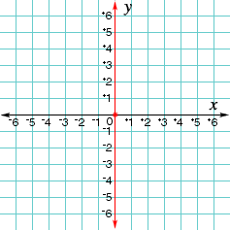 |  | I Have: Rate  Who has The four regions of a coordinate plane that are separated by the axes?  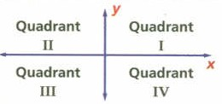
I Have: Quadrants  Who has The difference between the greatest and least numbers in a set of data? |  | I Have: Range  Who has Either of the two sides that form the right angle in a right triangle?  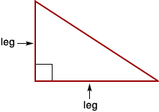
I Have: Leg (of a right triangle)

END OF GAME

