9.0 Scatter Plots and Equations of Lines

A graph of ordered pairs is called a scatter plot. We can use a scatter plot to determine whether or not a linear correlation (relationship) exists between two variables.

Positive correlation (as x increases, y increases)
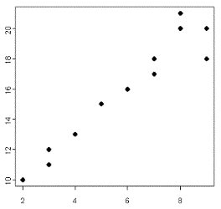

Negative correlation (as x increases, y decreases)
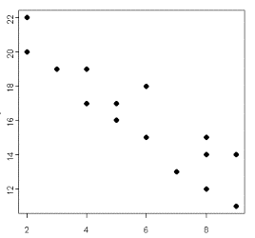

No correlation
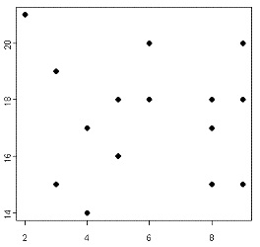

Example:

Data set Length and Wingspan of Hawks

Type of hawk length (in.) wing-span (in.)

Cooper’s 21 36
Crane 21 41
Gray 18 38
Harris’s 24 46
Roadside 16 31
Broad-winged 19 39
Short-tailed 17 35
Swanson’s 19 46

Step 1. Make a scatter plot of the data.

Step 2: Two points on the trend line are (14, 30) and (19, 39).

Find an equation of a line in y = mx + b form.

m = slope = y2 – y1 = 39 – 30 = 9 = 1.8
x2 – x1 19 – 14 5

30 = 1.8(14) + b

4.8 = b

Equation of the trend line is y = 1.8x + 4.8

Step 3: Predict the wingspan of a hawk that is 28 inches long.

y = 1.8(28) + 4.8

y = 55.2 inches

