Symbols

“sigma” – summation of values

x a variable that represents quantitative data entries

N number of entries in a population

n number of entries in a sample

“mu” – the population mean

“x bar” – the sample mean

2.3 Measures of Central Tendency

A measure of central tendency is a value that represents a typical, or central, entry of a data set.

Mean – average

Population mean:

Sample mean:

The median of a data set is the middle data entry when the data set is sorted in ascending order. If the data set has an even number of entries, the median is the mean of the two middle data entries.

The mode of a data set is the data entry that occurs with the greatest frequency. If no entry is repeated, the data set has no mode. If two entries occur with the same greatest frequency, both entries are modes and the data set is called bimodal.

Ex 1. Find the mean, median and mode of the following sample ages of a class. Which measure of central tendency best describes a typical entry?

20 20 20 20 20 20 21 21 21 21
22 22 22 23 23 23 23 24 24 65

Mean = 23.8

Median = 21.5

Mode = 20

A weighted mean is the mean of a data set whose entries have varying weights

Ex 2. You are taking a class in which your grade is determined from five sources; 50% from your test mean, 15% from your midterm, 20% from your final exam, 10% from your computer lab work, and 5% from your homework. Your scores are:

Test mean = 86
Midterm = 96
Final = 82
Computer lab = 98
Homework = 100

What is your course grade?

= 86*0.5 + 96*0.15 + 82*0.2 + 98*0.10 + 100*0.05 = 88.6

= 0.5 + 0.15 +0.20 + 0.10 + 0.05 = 1

= 89
The mean of a frequency distribution is approximates by

where x and f are the midpoints and frequencies of a class.

Ex 3. Find the mean

Classes f
1-7 3
8-14 2
15-21 5
22-28 7
29-35 1

First, find the midpoints (x’s)
Classes x f
1-7 4 3
8-14 11 2
15-21 18 5
22-28 25 7
29-35 32 1

n = 18

= = 18.4

The Shape of Distributions

Symmetric- a vertical line can be draw through the middle of a graph of the distribution and the resulting halves are approximately mirror images.

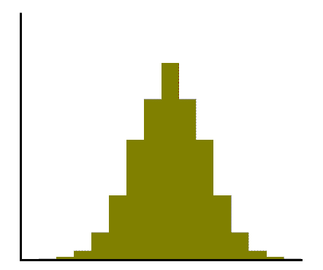

Uniform- all entries have equal frequencies

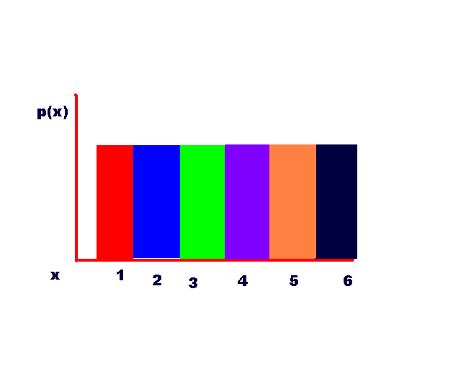

Skewed Left – tail extends to the left. The mean is brought down by a few entries on the left.

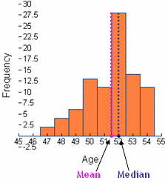
Skewed Right- tail extends to the right. The mean is brought up by a few data entries on the right.

