Creating a Podcast Using GarageBand

Follow these simple steps to create a podcast using GarageBand. Once you become comfortable using GarageBand you may want to try importing music, using video, or some more complex editing. Have fun!!

- Reasearch your topic.
- Write a script that you will be recording.
- Rehearse your script.
- Open GarageBand, Click on “Podcast” then click “Choose”, Give your podcast a name and click on “Create”.

Recording your Voice Track
- To record your voice, click on either the male or female voice track.

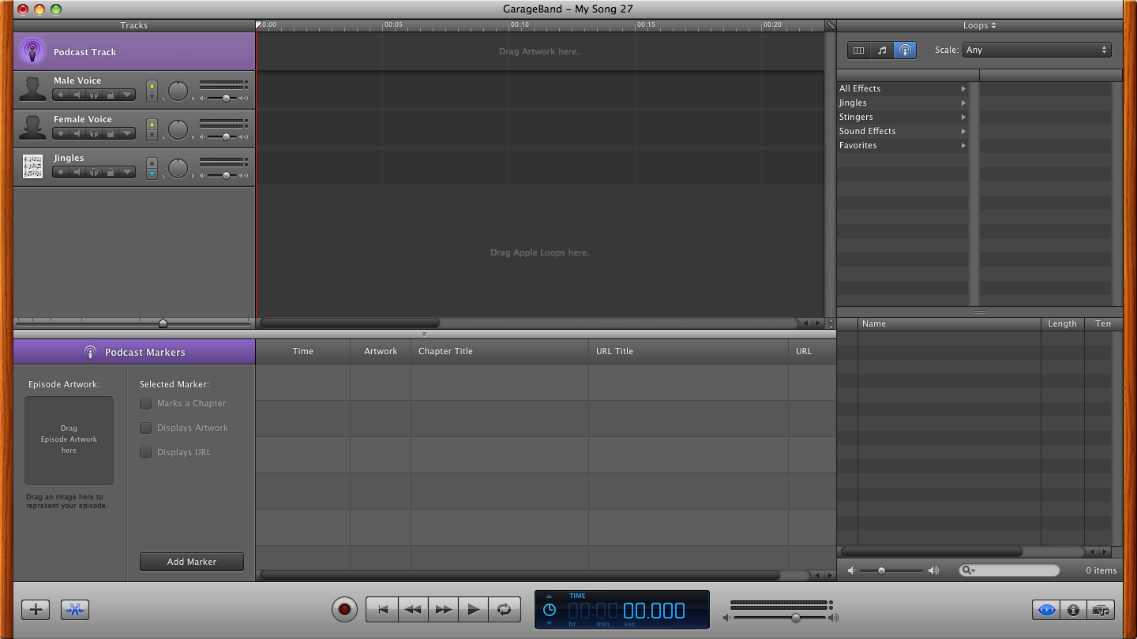

- Now click on the red record button and begin speaking, when you are finished speaking, click on the blue play button to stop recording.
- If you make a mistake and want to start over, simply click on your recorded voice track and press delete on your keyboard.
Adding Music

- Click on the Loop Browser “eye ball” to see the Jingles.
- Click on the name of a Jingle to hear it.
- After you have decided on a Jingle, click hold and drag it to the Jingle Track.
- You can add as many Jingles as you would like.
- To move your Jingles just click on them and drag them to a new location.
- To shorten a Jingle, move your cursor to the end of the Jingle and the cursor will change to a vertical line with arrows, click hold and drag to shorten the length of the jingle.

Adding Images

- Find the image you would like to add.
- Click hold and drag the image to the Podcast Track.
- Shorten the length and move your images to match your voice track.

Viewing Your Podcast

- Make sure you have moved your Playhead to the beginning of your show before playing.
- Click the play button.
- Make any adjustments to volume controls, images, etc.
- Save your Podcast
- Click on “Share”, click on “Send Podcast to iTunes”
- Podcasts can be viewed in iTunes or on your iPod.

