9.1 Correlation

A graph of ordered pairs is called a scatter plot. We can use a scatter plot to determine whether or not a linear correlation (relationship) exists between two variables.

Positive correlation (as x increases, y increases)
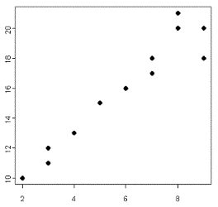

Negative correlation (as x increases, y decreases)
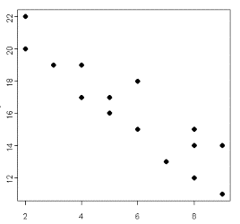

No correlation
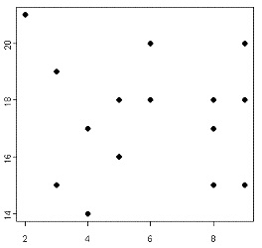

Example: Constructing a scatter plot.

Hours Slept  8  7  7  8  6  5  7  4  9  7 | Test Score  83  86  74  88  76  63  90  60  89  81

To construct a scatter plot using your calculator, put the x values in L1 and the y values in L2. Use Stat Plot to construct the scatter plot. Remember to also use Zoom Stat to view your graph.
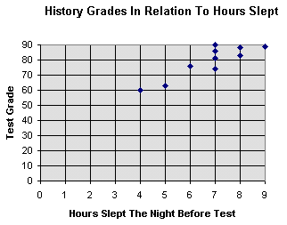

From the scatter plot, it appears that the variables have a positive correlation.

The Correlation Coefficient (r) measures the strength and direction of the linear relationship between two variables.

•If r is close to +1, x and y have a strong positive correlation

•If r is close to -1, x and y have a strong negative correlation

•If r is close to 0, there is weak correlation or none at all

To calculate r:

•STAT → CALC
4:LinReg (ax +b)
LinReg(ax +b) L1, L2 ENTER

t-Test for a Correlation Coefficient

To test whether or not you have a significant correlation between x and y, you can use a t-test.

Always test the following hypothesis:

(no significant correlation)
(significant correlation)

d.f. = n-2 where n is the number of pairs of data

The test statistics is

Example: Is there enough evidence to conclude that there is a significant linear correlation between hours slept and test score? Use .

(no significant correlation)
(significant correlation)

This is a two-tailed test where d.f. = 10-2 = 8

Critical values are

Test statistic = 5.325

Reject . There is a significant positive correlation between hours slept and test score.

Important note: Just because there is a significant correlation between two variables does not necessarily mean that there is a cause-and-effect relationship between the variables. It is always possible that there are other factors involved in the relationship. Other factors in the previous example include time spent studying, time spent paying attention in class, intelligence, etc.

