7.3 Hypothesis Testing for the Mean (Small Samples) –Rejection Regions

Example: An industrial company claims that the mean pH level of the water in a nearby river is 6.8. You randomly select 19 water samples and measure the pH of each. The sample mean and standard deviation are 6.7 and 0.24 respectively. Is there enough evidence to reject the company’s claim at ?

1. (claim)

2. Two-tailed test

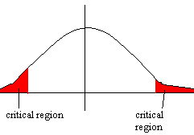
d.f. = 19-1 = 18

critical values are t =

3. test statistic

4. -1.816 is NOT in the rejection region, so we do not reject
Since represents the claim, do not reject the claim.

