2.5 Measures of Position

Fractiles are numbers that partition an ordered data set into equal parts.

The three quartiles Q1, Q2, and Q3 divide an ordered data set into four equal parts. 25% of the data falls on or below the first quartile, Q1. 50% of the data falls on or below the second quartile, Q2 (which is the same as the median). And 75% of the data falls on or below the third quartile, Q3.

Ex 1: Consider the following data set:

100 27 18 93 34 54 52 59 91 85 82 87 78 68 61

To find Q1, Q2 and Q3, first put the data in order:

Lower half upper half
↓ ↓
18 27 34 52 54 59 61 68 78 82 85 87 91 93 100
↑ ↑ ↑
Q1 Q2 (median) Q3

Interquartile Range (IQR) – in the difference between Q3 and Q1
IQR = Q3 – Q1

Box-and-Whisker Plots

Five number summary – min, Q1, med, Q3, max

Min =18
Q1 = 52
Median = 68
Q3 = 87
Max = 100

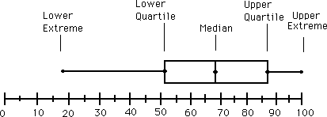

***For instructions on how to construct a box-and-whicker plot in your calculator, check out the link on the main moodle page.

Percentiles- divide a data set into one hundred equal parts. P1, P2, P3, …P99.
A percentile tells us what percent of the data is less than a certain data value.

SAT percentile ranks:

Another example of percentiles:
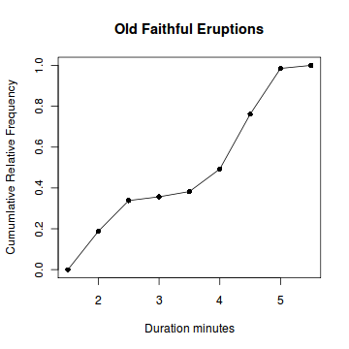

Calculating a percentile:

Ex: Your grade in stats is an 86. There are 52 students taking the class this semester, 31 of whom have a grade that is the same or lower than your. To calculate your percentile rank:

So, your grade is in the 60th percentile.

A z-score represents the number of standard deviations a given value x falls from the mean ,µ.

Ex: The mean SAT score for mathematics in 515 with a standard deviation of 116. Three students have scores 400, 520 and 750. Find the three z-scores and decide if any of them are unusual.

= -0.99 = 0.04 = 2.03

Z-scores that are greater than 2 or less than -2 are considered unusual. If a data value has a corresponding z-score that is greater than 3 or less than -3, it is considered very unusual.

