2.2 More Graphs and Displays

Stem-and-Leaf Plots
Stem-and-leaf plots are a method for showing the frequency with which certain classes of values occur. You could make a frequency distribution table or a histogram for the values, or you can use a stem-and-leaf plot and let the numbers themselves to show pretty much the same information.
For instance, suppose you have the following list of values: 12, 13, 21, 27, 33, 34, 35, 37, 40, 40, 41. You could make a frequency distribution table showing how many tens, twenties, thirties, and forties you have:
Frequency  Class | Frequency
10 - 19 | 2
20 - 29 | 2
30 - 39 | 4
40 - 49 | 3
You could make a histogram, which is a bar-graph showing the number of occurrences, with the classes being numbers in the tens, twenties, thirties, and forties:
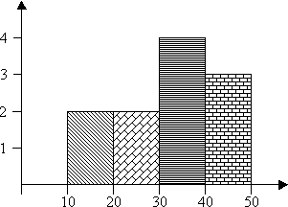
(The shading of the bars in a histogram isn't necessary, but it can be helpful by making the bars easier to see, especially if you can't use color to differentiate the bars.)

The downside of frequency distribution tables and histograms is that, while the frequency of each class is easy to see, the original data points have been lost. You can tell, for instance, that there must have been three listed values that were in the forties, but there is no way to tell from the table or from the histogram what those values might have been.
On the other hand, you could make a stem-and-leaf plot for the same data:
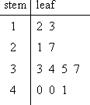
The "stem" is the left-hand column which contains the tens digits. The "leaves" are the lists in the right-hand column, showing all the ones digits for each of the tens, twenties, thirties, and forties. As you can see, the original values can still be determined; you can tell, from that bottom leaf, that the three values in the forties were 40, 40, and 41.
Note that the horizontal leaves in the stem-and-leaf plot correspond to the vertical bars in the histogram, and the leaves have lengths that equal the numbers in the frequency table.

- Complete a stem-and-leaf plot for the following list of grades on a recent test:
73, 42, 67, 78, 99, 84, 91, 82, 86, 94
I'll use the tens digits as the stem values and the ones digits as the leaves. For convenience sake, I'll order the list, but this is not required:
42, 67, 73, 78, 82, 84, 86, 91, 94, 99
1999-2009 All Rights Reserved
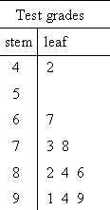

Dot plots
Here is an example to show what a dotplot looks like and how to interpret it. Suppose 30 first graders are asked to pick their favorite color. Their choices can be summarized in a dotplot, as shown below.
*  *  *  *  *  *  *  *  * | *  * | *  *  * | *  *  *  *  * | *  *  *  *  *  *  * | * | *  *  *
Red | Orange | Yellow | Green | Blue | Indigo | Violet
Each dot represents one student, and the number of dots in a column represents the number of first graders who selected the color associated with that column. For example, Red was the most popular color (selected by 9 students), followed by Blue (selected by 7 students). Selected by only 1 student, Indigo was the least popular color.

Pie charts

The following example chart is based on preliminary results of the election for the European Parliament in 2004. The following table lists the number of seats allocated to each party group, along with the derived percentage of the total that they each make up. The values in the last column, the derived central angle of each sector, is found by multiplying the percentage by 360°.
Group | Seats | Percent (%) | Central angle (°)
EUL | 39 | 5.3 | 19.2
PES | 200 | 27.3 | 98.4
EFA | 42 | 5.7 | 20.7
EDD | 15 | 2.0 | 7.4
ELDR | 67 | 9.2 | 33.0
EPP | 276 | 37.7 | 135.7
UEN | 27 | 3.7 | 13.3
Other | 66 | 9.0 | 32.5
Total | 732 | 99.9* | 360.2*
*Because of rounding, these totals do not add up to 100 and 360.
The size of each central angle is proportional to the size of the corresponding quantity, here the number of seats. Since the sum of the central angles has to be 360°, the central angle for a quantity that is a fraction Q of the total is 360Q degrees. In the example, the central angle for the largest group (European People's Party|EPP) is 135.7° because 0.377 times 360, rounded to one decimal place(s), equals 135.7.
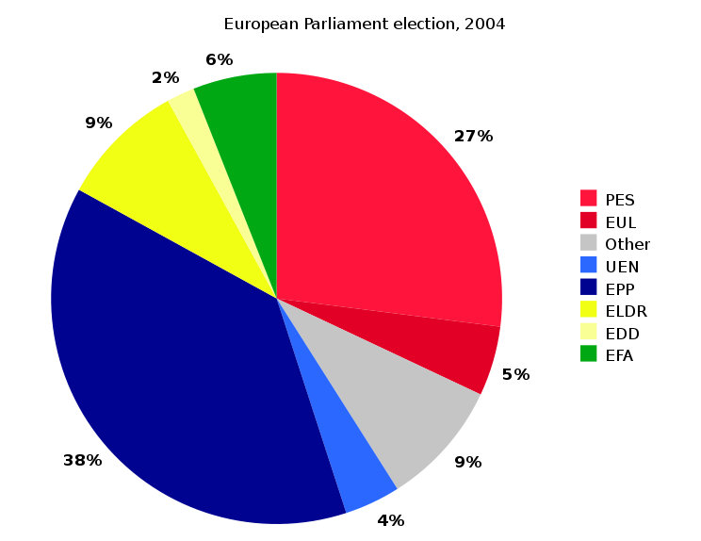

Pareto Charts

A Pareto chart is a bar graph. The lengths of the bars represent frequency or cost (time or money), and are arranged with longest bars on the left and the shortest to the right. In this way the chart visually depicts which situations are more significant.

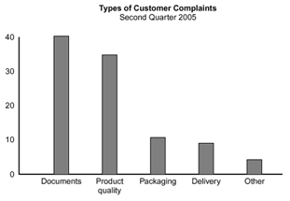

Time Series Chart

