2.4 Measures of Variation

Range= maximum entry – minimum entry

Ex 1. Two corporations each hired 10 graduates. The starting salaries for each are as follows:

Corporation A (1000s of dollars)
41 38 39 45 47 41 44 41 37 42

Corporation B (1000s of dollars)
40 23 41 50 49 32 41 29 52 58

•Find the mean, median, and mode of each data set

A: mean = 41.5, median = 41, mode = 41
B: mean = 41.5, median = 41, mode = 41

**Both data sets have the same mean, median and mode, and yet the two sets differ significantly. The first difference between the data sets is the range.

•Find the range of each data set

A: 47- 37 = 10
B: 58- 23 = 35

**The second set of data has a great variation. Your goal in this section is to learn how to measure the variation of a data set.

The deviation of an entry x in a population data set is the difference between the entry and the mean, µ, of the data set.

•Find the deviation of each starting salary for corporation A.
Salary, x Deviation x- µ
41 -0.5
38 -3.5
39 -2.5
45 3.5
47 5.5
41 -0.5
44 2.5
41 -0.5
37 -4.5
42 0.5

If we want to find the average amount that each data entry varies from the mean, it would make sense to add up all the deviations and divide by how many there are. However, if we add up all the deviations: = 0. Because this is true for ALL data sets, we need to find a way to overcome this. To do this, we square each deviation.

Salary, x Deviation x- µ squares
41 -0.5 0.25
38 -3.5 12.25
39 -2.5 6.25
45 3.5 12.25
47 5.5 30.25
41 -0.5 0.25
44 2.5 6.25
41 -0.5 0.25
37 -4.5 20.25
42 0.5 0.25
In a population data set, the mean of the squares of the deviations is called the population variance.

•population variance =

•population standard deviation =

Ex 2. Find the population variance and standard deviation for corporation A:

Salary, x squares
41 0.25
38 12.25
39 6.25
45 12.25
47 30.25
41 0.25
44 6.25
41 0.25
37 20.25
42 0.25
= = 8.85

•We rarely use the variance as a useful measurement because the units do not make sense since they are squared. In this case, the variance is 8.85 dollars squared.

•The standard deviation is a more widely used, more important measurement.
= = = 2.97

Sample variance:

Sample standard deviation:

Ex 3. Suppose corporation B is only one branch of a whole company and you plan to use the starting salaries of corporation B to estimate the salaries of the whole company. (Use sample statistics to estimate population parameters.)

Remember: the mean, = 41.5

Salary (x)
40 2.25
23 342.25
41 0.25
50 72.25
49 56.25
32 90.25
41 0.25
29 156.25
52 110.25
58 272.25
= 1102.5

= = 122.5

s = = 11.07

What Does Standard Deviation Mean?
1. A measure of the dispersion of a set of data from its mean. The more spread apart the data, the higher the deviation.
2. In finance, standard deviation is applied to the annual rate of return of an investment to measure the investment's volatility. Standard deviation is also known as historical volatility and is used by investors as a gauge for the amount of expected volatility.

The following three normal distributions all have a mean of 0, the first has the smallest standard deviation, the third has the largest standard deviation.

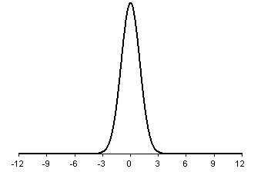

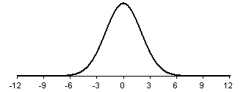

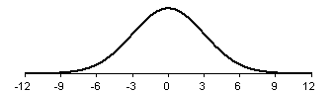

Sample Standard Deviation for grouped data (frequency distribution).

Ex 4. Find the sample standard deviation.

Kids (x) houses (f)
0 10
1 19
2 7
3 7
4 2
5 1
6 4

First, find the mean

n = total frequency = 50

0*10 + 1*19 + 2*7 +3*7 + 4*2 + 5*1 + 6*4 = 1.8
50

Kids (x) houses (f)
0 10 32.4
1 19 12.16
2 7 0.28
3 7 10.08
4 2 9.68
5 1 10.24
6 4 70.56

= 145.4
= = 1.72

More interpretations of standard deviation…

Chebychev’s Theorem

*applies to ALL distributions

•The proportion of any data set lying within k standard deviations (k > 1) of the mean is at least

•k = 2: In any data set, at least = = = 75% of the data lie within 2 standard deviations of the mean.

•k = 3: In any data set, at least = = = 88.9% of the data lies within 3 standard deviations of the mean.

Empirical Rule

In a normal distribution with mean, , and a standard deviation, , you can approximate areas under the normal curve as follows:

1. About 68% of the area lies between - and +. (red area on the bell curve)

2. About 95% of the area lies between -2 and +2. (red and green)

3. About 99.7% of the area lies between -3 and +3. (red, green and blue)

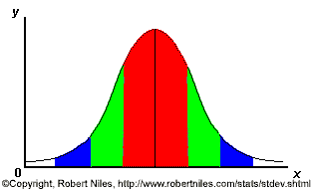

Ex 5. SAT scores (math and verbal) are normally distributed with a mean of 1000 and a standard deviation of 100.

a. Estimate the percent of scores between 800 and 1200.

On the left side of the mean, 800 is 2 standard deviations away,-2. On the right side, 1200 is 2 standard deviations away +2.

So, 95% of all scores fall between 800 and 1200.

b. Between what two values does 68% of the scores lies?

68% of the area lies between - and +. Left side: - = 1000 – 100 = 900. Right side: + = 1000 + 100 = 1100.

(900, 1100).

