9.2 Linear Regression

The equation of the regression line, also know as a trend line, or, line of best fit, is a line in the form of y = mx +b that allows you to predict y-values if the correlation between x and y is significant.

Example:

Sandwich | Total Fat (g) | Total Calories
Hamburger | 9 | 260
Cheeseburger | 13 | 320
Quarter Pounder | 21 | 420
Quarter Pounder with Cheese | 30 | 530
Big Mac | 31 | 560
Arch Sandwich Special | 31 | 550
Arch Special with Bacon | 34 | 590
Crispy Chicken | 25 | 500
Fish Fillet | 28 | 560
Grilled Chicken | 20 | 440
Grilled Chicken Light | 5 | 300

Once I put the Xs (total fat) into L1 and the Ys (total calories) into L2, I pulled up the graph.

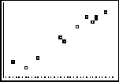
It looks like I have a positive correlation.

•Find the equation of the regression line:

1. Find your r value and perform a t-test to make sure it is significant. If the correlation is not significant, there is no regression line!

1. Open the STAT menu.

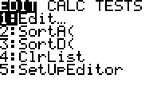
STAT
2. Move cursor to CALC.

STAT
STAT
STAT
ZOOM
ENTER
3. Select LinReg(ax+b),
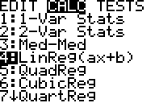

4. LinReg(ax +b) L1, L2

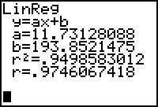

Let’s pretend that we already did our t-test and found out that the r value of .975 is significant.

To find the equation of the regression line, just plug in a and b to the equation
y = ax +b.

The equation of this regression line is y = 11.731x + 193.852

•To add this equation to my scatter plot, hit the Y= key and then type the equation into Y1 then hit GRAPH
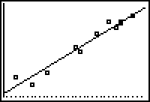

Remember to ZOOMSTAT if it does not come up right away.

•To use this equation to predict values of y, simply plug in an x value.
Example:
Predict the total calories in a sandwich that has 18 grams of total fat.

y = 11.731x + 193.852

y = 11.731(18) + 193.852= 405 total calories

