7.2 Hypothesis Testing for the Mean (Large Samples) using Rejection Regions

Example: In an advertisement, a pizza shop claims that its mean delivery time is less than 30 minutes. A random sample of 36 delivery times has a sample mean of 32 minutes and a standard deviation of 3.4 minutes. Is there enough evidence to reject the claim at ?

1. :
: (claim)

2. Left-tailed test

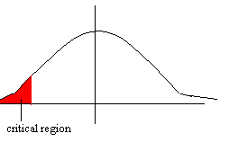
The area of the critical region is 0.01, so look on the chart to find the critical value of
Z = -2.33.

3. Find the test statistic.

=

= 3.43

4. z = 3.43 is NOT in the rejection region so:

We do NOT reject.
We do reject.

Since represents the claim, we reject the claim.

