6.2 Confidence Intervals for the Mean for Small Samples

The t-distribution

In many real-life situations because of restraints such as time and cost, it is not feasible to collect a sample of 30 or more. So, how do you construct a confidence interval for a population mean given these circumstances?

If the random variable is normally distributed (or approximately normally distributed) the sampling distribution for is a t-distribution where

Critical values of t are denoted .

Properties of the t-distribution

1. The t-distribution is bell-shaped and symmetric about the mean.

2. The t-distribution is a family of curves determined by a parameter called the degrees of freedom. The degrees of freedom are the number of free choices left after a sample statistic such as is calculated. When you use the t-distribution to estimate a population mean, the degrees of freedom is equal to one less than the sample size.

d.f. = n-1

3. The total area under a t-curve is 1 or 100%.

4. The mean, median, and mode of the t-distribution are all equal to 0.

5. As the degrees of freedom increase, the t-distribution approaches the normal distribution. After 30 d.f., the distribution is very close to the standard normal z-distribution.

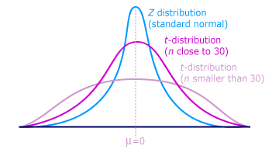

Notice that the tails in the t-distribution are thicker than those in the standard normal distribution.

Guidelines for constructing a confidence interval for the mean.

Example:

A sample of 25 randomly selected students has a mean test score of 81.5 with a standard deviation of 10.2. Construct a 95% confidence interval for the population mean.

1. Since n < 30, use the t-distribution (if n 30, refer back to section 6.1 and use the normal distribution)

2. Identify the sample statistics

n = 25
= 81.5
s = 10.2

3. Identify the degrees of freedom and the level of confidence, c to find the critical value from your chart.

d.f. = 25 - 1 = 24
c= .95

= 2.064

4. Find the error margin:

E = 2.064 *

E = 4.21

4. Find the left and right endpoints and form the confidence interval.

Left endpoint:
Right endpoint:

Interval: (81.5 – 4.21, 81.5 + 4.21)

(77.29, 85.71)

