Correcting Faulty Parallelism
Faulty parallelism occurs when a writer uses unequal grammatical structures to express related ideas.

Correct a sentence containing faulty parallelism by rewriting it so that each parallel idea is expressed in the same grammatical structure.
Faulty parallelism can involve words, phrases, and clauses in a series or in comparisons.
Nonparallel Words, Phrases, and Clauses in a Series Always check a series of ideas in your writing for parallelism. If, for example, you begin a series with a prepositional phrase, make all the items in the series prepositional phrases.
The chart at the top of the next page presents some nonparallel structures and shows how they can be rephrased to restore smoothness and clarity to the sentence. Notice how coordinating conjunctions (such as and, but, or) often connect the items in a series and can signal you to check the connected items for parallelism.
Another potential problem to note involves correlative conjunctions, such as both . . . and or not only . . . but also. Though these conjunctions connect two related items, writers sometimes misplace or split the first part of the conjunction. The result is faulty parallelism.
NONPARALLEL: | Our lifeguard not only won the local surfing championship but also the state title.
PARALLEL: | Our lifeguard won not only the local surfing championship but also the state title.

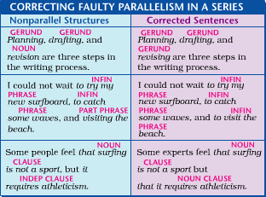
Nonparallel Words, Phrases, and Clauses in Comparisons As the old saying goes, you cannot compare apples with oranges. In writing comparisons, you generally should compare a phrase with the same type of phrase and a clause with the same type of clause. Furthermore, you should make sure your ideas themselves, as well as the structures you use to express them, are logically parallel.
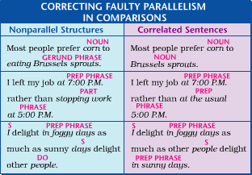

NAME_________________________________

Correcting Faulty Parallelism
Directions:
Revise the following sentences as needed to correct faulty parallelism. If a sentence is already in proper parallel form, write correct.

- At age 22, Benjamin Franklin began publishing the Pennsylvania Gazette, and he wrote most of the articles.

___________________________________________________________________________

___________________________________________________________________________

- Franklin is credited with being the first editor to publish a newspaper cartoon and illustrating a story with a map.

___________________________________________________________________________

___________________________________________________________________________

- Franklin began Poor Richard’s Almanac to educate, entertain, and for the enlightenment of Americans.

___________________________________________________________________________

___________________________________________________________________________

- Poor Richard’s Almanac contains many wise and witty saying that preach the virtues of industry, frugality, and honesty.

___________________________________________________________________________

___________________________________________________________________________

- Franklin introduced many needed reforms to the post office, including a Dead Mail Office, more post riders, and had mail delivered night and day.

___________________________________________________________________________

___________________________________________________________________________

