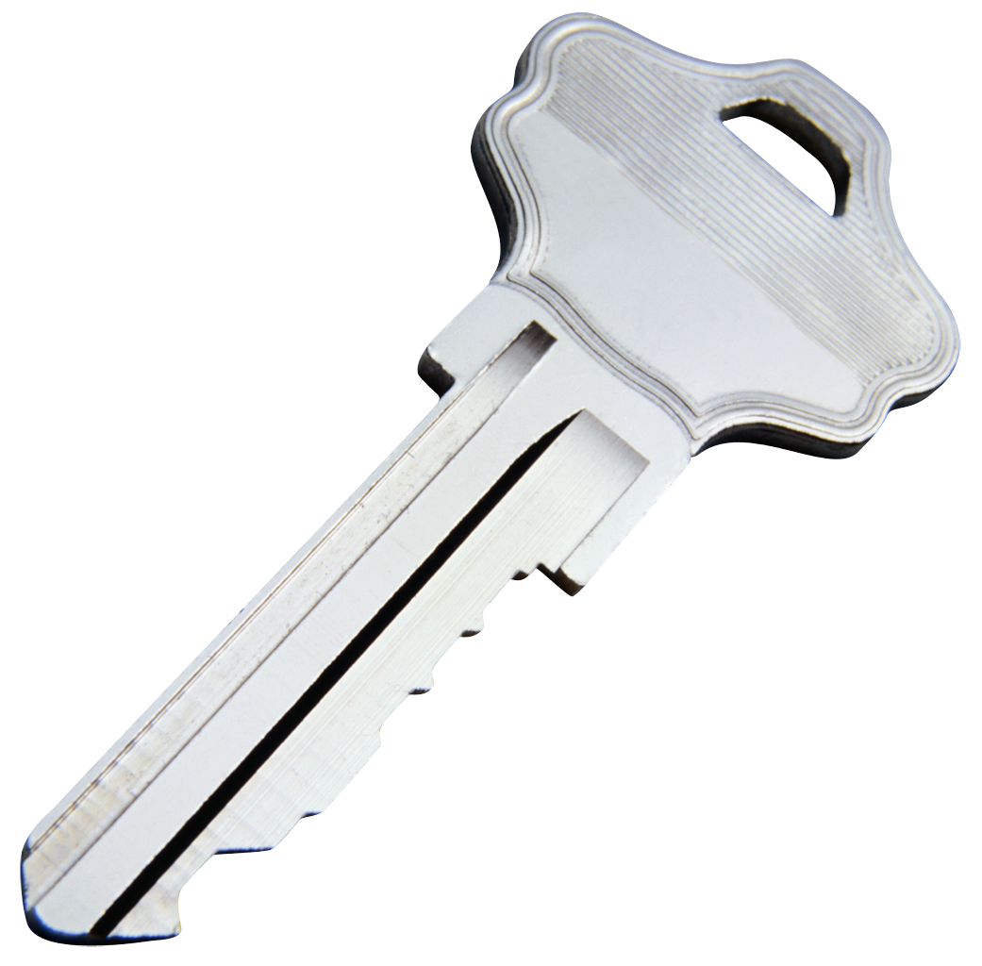
Analyze & answer the question

Note plan

Skim, Read & Select

Write response to the question

ER End by reviewing

